# What we will be doing as part of this exercise:

1. Create Java artifact (Runnable Jar)
2. Create Dockerfile to build Docker Image
3. Upload Image to DockerHub (Public Repository)
4. Download and Run the standalone application in another machine with simple commands.

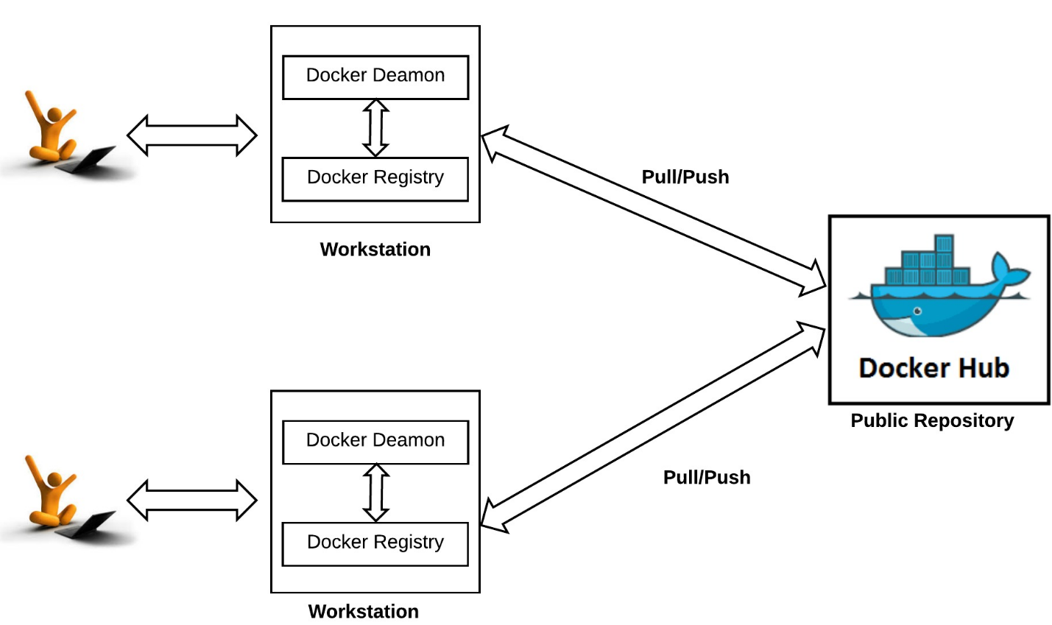

# Assignment 1:

1. Download or Clone the following repository from [Git](https://github.com/mbzama/docker-training), this contains infrastructure code and source code to get started.

**event-processor** maven project contains a simple java class with the following code:

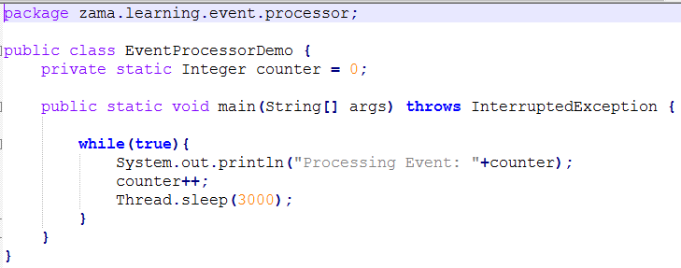

1. Extract (or) Copy the “docker-training” directory to “C:/Users/{User}”
2. Import “event-processor” project into IDE (Or) Just run the Maven/ANT commands to build the required artifact.
3. Please change the output folder in “build.xml” to reflect your local directory. When we build the application with **ant** it would basically copy the artifact (Jar) to the specified location.

i.e., C:/Users/{User}/docker-training/infrastructure-code

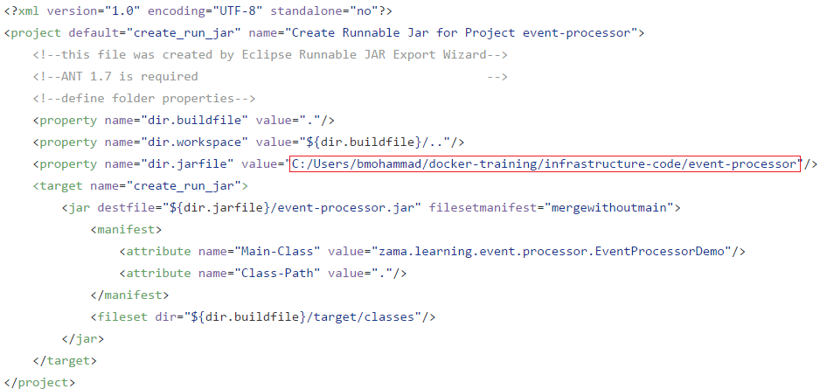

1. Startup Docker Toolbox application:

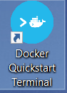

1. Overview of commands in **update.sh** file

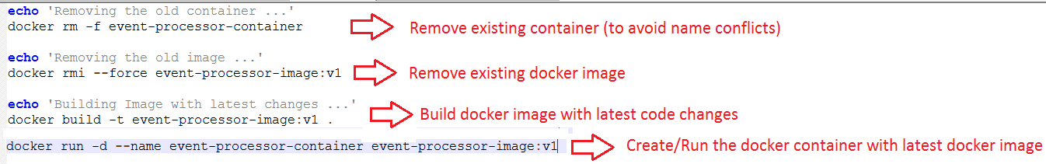

1. Navigate to C:/Users/{User}/docker-training/infrastructure-code and run the following command: **sh update.sh**

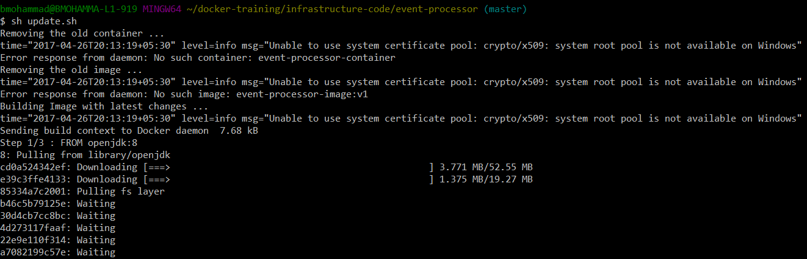

1. Verify the status of the container by running this command: **docker ps**



1. If the application is running as daemon process, verify the logs using this command:

